EXPERIMENT 6
EDA – GROUPING AND AGGREGATION
Aim
To perform grouping and aggregation on the Stroke Prediction dataset using Pandas and analyze patient characteristics based on different categories.
Procedure
- Load the Stroke Prediction dataset using Pandas.
- Group patients based on gender.
- Calculate the total number of patients in each gender.
- Calculate average age and average glucose level for each gender.
- Analyze stroke cases based on gender using cross-tabulation.
- Group patients based on work_type.
- Calculate total patients and average glucose level for each work type.
- Create a bar chart to visualize patients by gender.
- Display the analysis results.
Python Code
import pandas as pd
import matplotlib.pyplot as plt

# Load dataset
df = pd.read_csv("healthcare-dataset-stroke-data.csv")

# 1. Group by Gender
gender_analysis = df.groupby("gender").agg(
Total_Patients=("id", "count"),
Average_Age=("age", "mean"),
Average_Glucose_Level=("avg_glucose_level", "mean")
)

print("Gender Analysis:")
print(gender_analysis)

# 2. Stroke analysis by Gender
stroke_analysis = pd.crosstab(
df["gender"],
df["stroke"]
)

print("\nStroke by Gender:")
print(stroke_analysis)

# 3. Group by Work Type
work_analysis = df.groupby("work_type").agg(
Total_Patients=("id", "count"),
Average_Age=("age", "mean"),
Average_Glucose_Level=("avg_glucose_level", "mean")
)

print("\nWork Type Analysis:")
print(work_analysis)

# 4. Bar chart
gender_analysis["Total_Patients"].plot(
kind="bar"
)

plt.title("Patients by Gender")
plt.xlabel("Gender")
plt.ylabel("Number of Patients")
plt.xticks(rotation=0)
plt.show()
CODE OUTPUT
Gender Analysis
Gender Analysis:
Total_Patients Average_Age Average_Glucose_Level
gender
Female 2994 43.757395 104.057809
Male 2115 42.483385 109.088520
Other 1 26.000000 143.330000

Stroke by Gender:
stroke 0 1
gender
Female 2853 141
Male 2007 108
Other 1 0

Work Type Analysis:
Total_Patients Average_Age Average_Glucose_Level
work_type
Govt_job 657 50.879756 107.779772
Never_worked 22 16.181818 96.042727
Private 2925 45.503932 106.796844
Self-employed 819 60.201465 112.645446
children 687 6.841339 94.400277
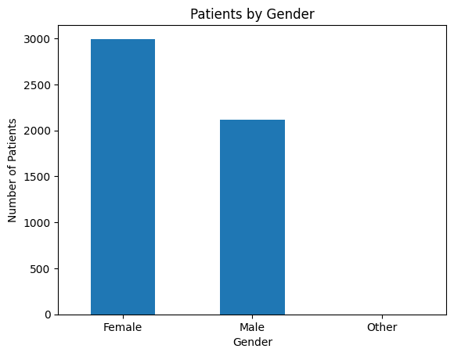
Result
The Stroke Prediction dataset was successfully grouped and aggregated using Pandas. The analysis identified differences in patient count, average age, average glucose level, and stroke cases across gender and work type categories.

